Basketball Game  
  
  
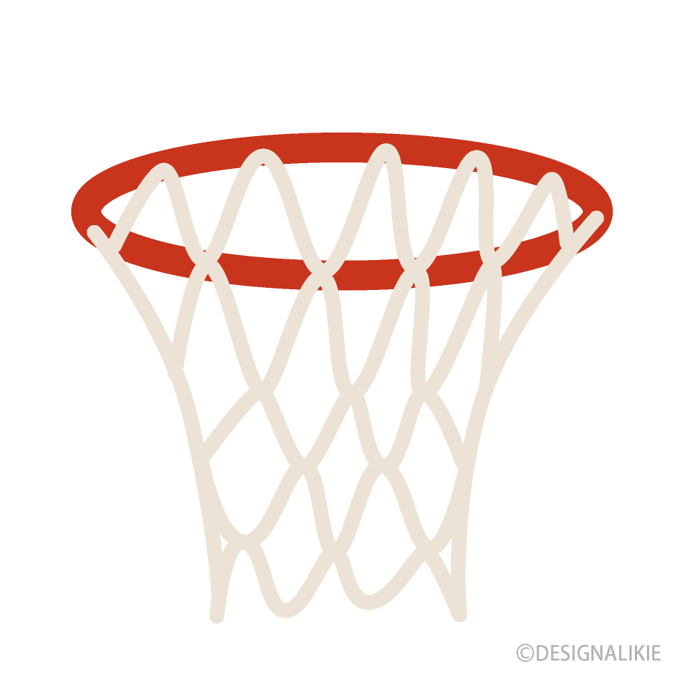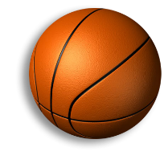  


Basketball: Basket rings are the playing characters we need to pull them to release the ball and send it to the 2nd ring. We can score by getting the ball in the next ring safely without falling



Be A Archer!!: IN this game we need to stop the lines at a certain position to get the gola and the point the lines will move automatically and will stop when we touch or click on the screen. Score can be made by hitting the arrow at the correct area.